

UNIFORM POLICY

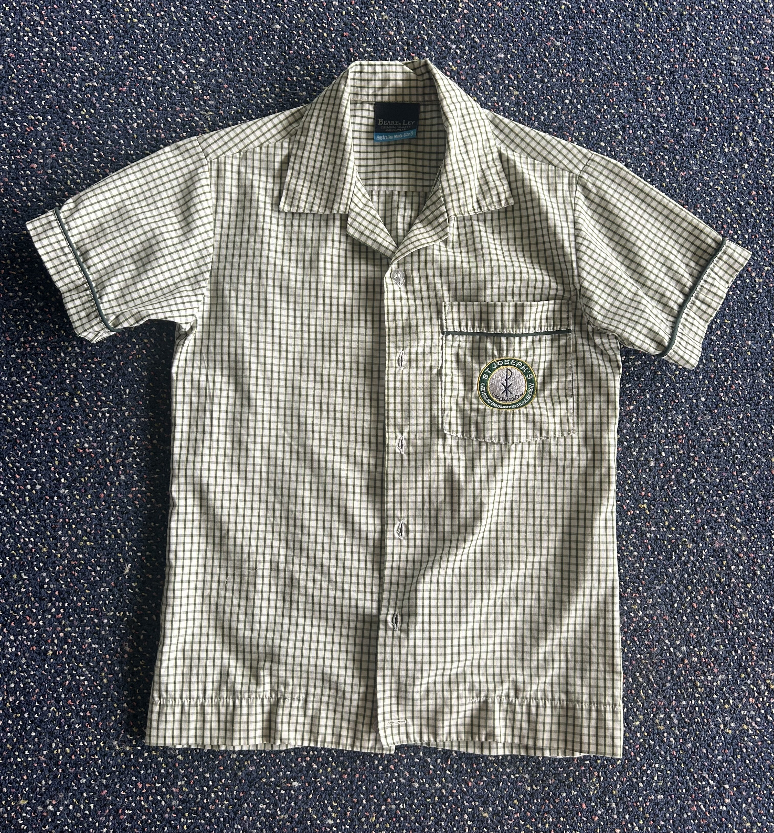
DAY UNIFORM
Girls
Bottle green Beare and Ley culottes STYLE CODE: LGCBG/78904
(Please note: no skirts or shorts with a skirt front are acceptable)
School shirt with embroidered school badge

BOYS
Bottle green blockers Beare and Ley shorts STYLE CODE: LGSBG/95034
(Please note: no cargo shorts are acceptable)
School shirt with embroidered school badge

SPORTS UNIFORM
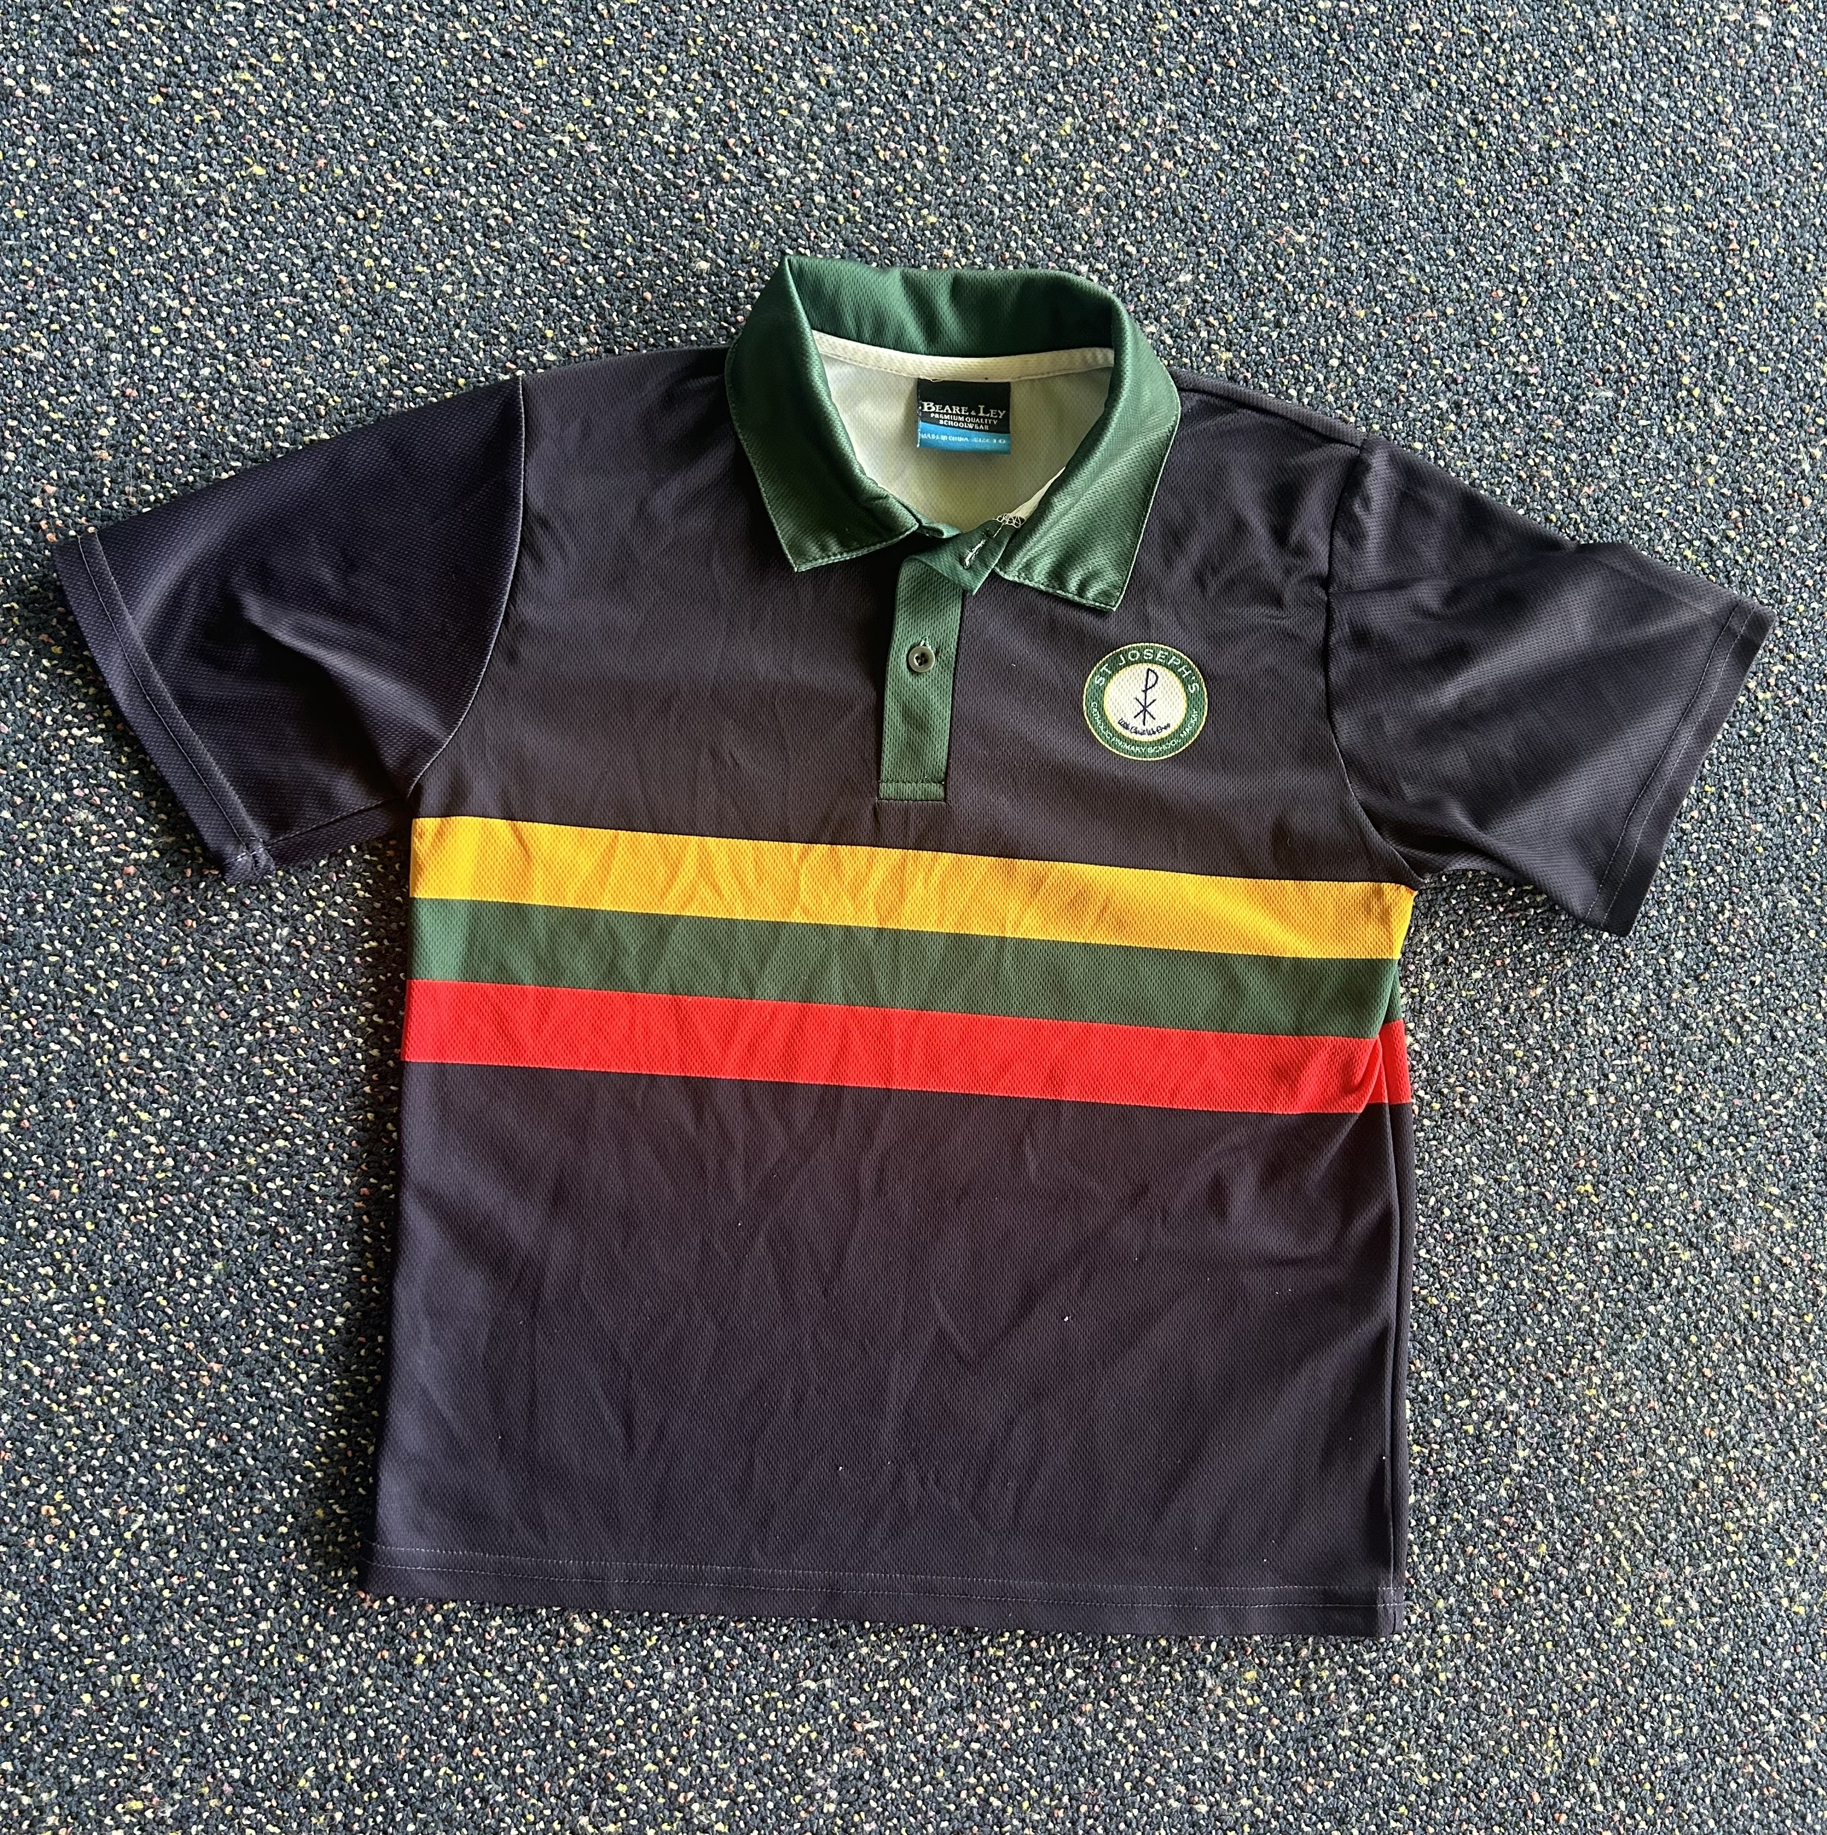
Girls
Navy blue polo shirt with gold, green and red horizontal stripes
Bottle green culottes (as per day uniform) or sports shorts with logo

BOYS
Navy blue polo shirt with gold, green and red horizontal stripes
Bottle green shorts (as per day uniform) or sports shorts with logo

Parents will be informed as to which days each class will be required to wear their sports uniform through class communication. These are the only days the sports uniform is to be worn unless notified.

ALL STUDENTS
HAT: reversible house colour bucket hat with school logo (HIGHLY RECOMMEND name embroidered)
SOCKS: white socks (quarter crew/quarter sport – not ankle socks)

PLAIN BLACK LEATHER SPORTS SHOE:
- The entire foot is to be enclosed by the shoe
- The shoe is to have either black laces or Velcro
- Shoes made from open weave materials such as canvas, cotton or similar will not be permitted

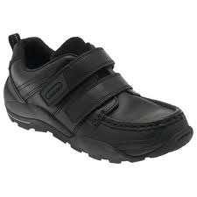

PERMITTED SHOES
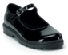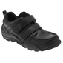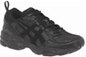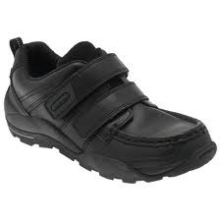

SHOES NOT PERMITTED
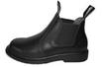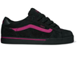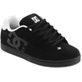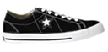

WINTER UNIFORM
Green fleece zip front jacket with school logo (HIGHLY RECOMMEND name embroidered)
Green fleece tracksuit pants

GIRLS: bottle green opaque tights only (to be worn under culottes)

JEWELLERY
Earrings – plain studs / plain sleepers – 1 set only
Chain with cross / religious medallion under shirt
Wrist watches – no smart devices
Cygnet ring
(Please note: Bangles and decorative rings are not permitted)

HAIR AND GROOMING
BOYS
Minimum cut - gauge 2 – no shorter / no tracks / no “rats” tails / no mullets
Hair be tied back if it is collar length or longer, neatly and off face
Natural colour

Neat, tidy and styled off face if shoulder length or shorter
Hair be tied back if it is collar length or longer, neatly and off face
Natural colour
Hair Accessories: Plain bottle green, gold or navy only (hair ties, hair bands, clips, ribbons – no embellishments) or school uniform fabric accessories
(Please note: Nail polish and make-up is not permitted)

UNIFORM STOCKISTS:

LOWES
Canelands
Mangrove Road
Mackay QLD 4740

Uniform Solutions
Shop 2, 88 Sydney Street
Mackay QLD 4740

